
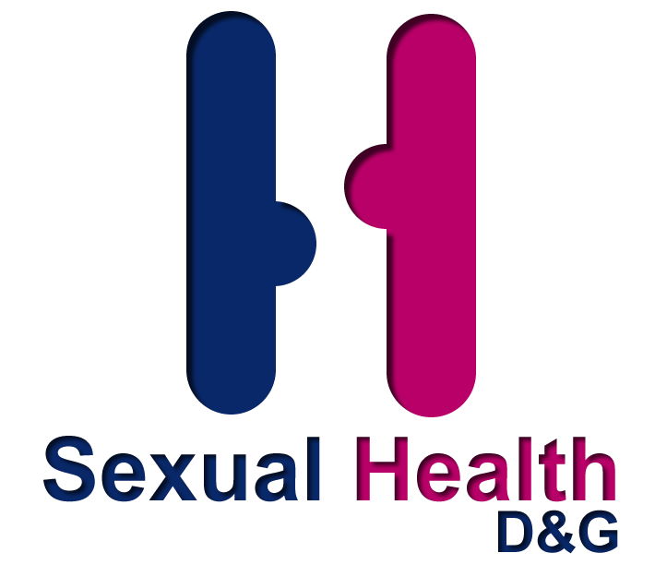



‘LET’S TALK ABOUT SEX – NO GIRLS ALLOWED’
DUMFRIES & GALLOWAY’S SEXUAL HEALTH WEEK
22nd -29TH JANUARY 2011

GOT THE SEX FACTOR?



Get 10 out of 10 by being a clever dick. Get tested to score!

This is Dumfries & Galloway’s 4th consecutive sexual health awareness week and the focus this year will be on men’s sexual health. Gender is an important factor in determining sources of health information. Women are more likely to seek advice from peers, magazines, books, and the television than men. Health is often viewed as a woman’s domain with sexual health information and services often aimed at women. Also men, both young and old, are less likely to access health services including sexual health services. Therefore, the aim of this week is to raise awareness of sexual health issues for men of all ages including the following topics

Under 25’s Chlamydia testing
Older men’s sexual health
Sexual dysfunction
Dating
‘The middle age spread’ (STIs in over 50’s)

Under 25’s Chlamydia testing:

Sexually active under 25’s are at greatest risk of contracting Chlamydia. In Dumfries & Galloway more young women than young men are tested. We will be raising awareness and encouraging more men under 25 to be tested. Resources to promote this will be available.

Older men’s sexual health

The media might tell you that sex is only for the young and beautiful, don't believe it. The need for intimacy is ageless. Sex may not be the same as it was in your 20s, but it can still be as fulfilling as ever. Sexual activity among older people can still be viewed by society as taboo and as a consequence older people can be ashamed or embarrassed to admit to being sexually active. Sex is not all about reproduction and penetration. There are many health benefits, physical and emotional as well as sexual pleasure in having an active sex life. ‘Sexual health and aging’ fact file available to use.

Sexual dysfunction.
‘Can’t get it up, Can’t get it down, Can’t get it in, Can’t get it out, Comes too fast, Comes too slow(or not at all), It hurts( or I think it will hurt), I don’t want to do it!’. Top 10 tips for considering sexual dysfunction and Pathway for referral for sexual dysfunction available to use.
Dating
‘Have we met before?’ Poster with information to raise awareness of common sexually transmitted infections.

‘The middle age spread’ (Sexually Transmitted Infections (STI’s) in over 50’s)
STI’s do not know any age barriers and rates of STI’s are rising in people over 50 as a result of unprotected sex. Increasingly older people are likely to be single or experiencing new relationships. With more international travel and internet dating the opportunities for meeting new people has increased. Posters from Family Planning Association (FPA) recent sexual health awareness week on this subject are available to display.

Resources available from Sexual Health D&G to help you plan activities for the week:

‘Got the sex factor’ – business cards and flyers with condoms
Postal testing kits for Chlamydia
Condoms – a range are available
Leaflets –a range are available
‘Sexual health and aging’ fact file
Top 10 tips for considering sexual dysfunction
Pathway for referral for sexual dysfunction
Dating poster
FPA middle age spread posters

Some resources are also available to downloaded at www.c4urself.org.uk

Sexual Health D&G Contacts:

Maggie Gurney Director of Sexual Health D&G
mgurney@nhs.net
Fiona Gleghorn Nurse Co-ordinator
fiona.gleghorn@nhs.net

Adele Hannah YP’s Sexual Health Co-ordinator
adele.hannah@nhs.net
Laura Fairbairn
Health Improvement Programme Lead-Sexual Health
laura.fairbairn@nhs.net

Banks I. (2001). ‘No man’s land: men, illness and the NHS’. British Medical Journal, Vol. 323, No. 7320, pp 1058-1060. Accessed on line 28th October 2010

